**SALES DATA CLEANING**

|  |  |
| --- | --- |
| **For the unclean data:** | [**Click Here**](https://docs.google.com/spreadsheets/d/1_nXdYH-ceuSyEy8W7eJnm-HtvqTTkRo9eS7nYxv7IYo/edit?gid=0#gid=0) |

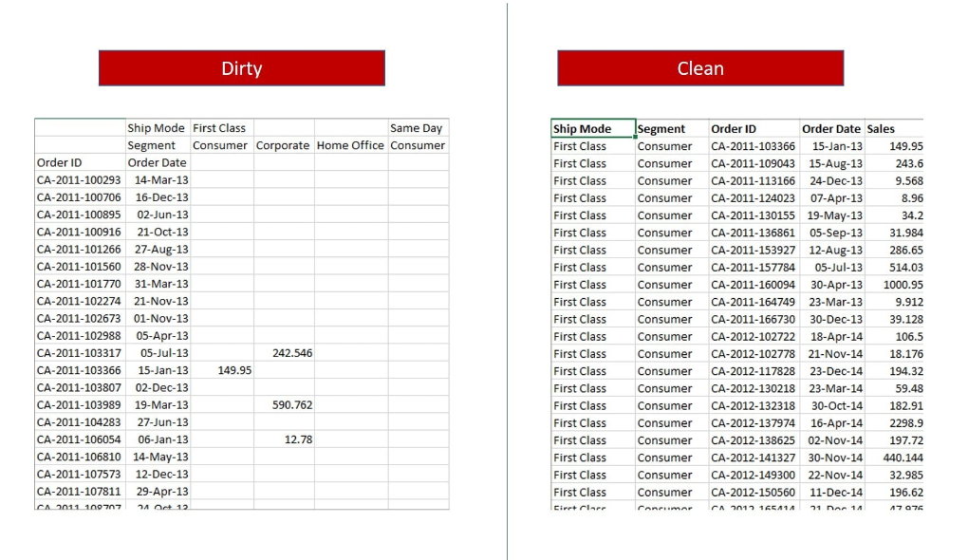

# **1. INTRODUCTION**

Data quality plays a crucial role in making accurate, data-driven decisions. Raw datasets often contain inconsistencies such as missing values, incorrect data types, and redundant information, which can lead to misleading insights.

This report outlines the process of cleaning and refining a dataset that initially contained 823 records and 14 columns. The dataset had:

* Missing values in several columns.
* Incorrect data types, with the Segment column stored as datetime instead of categorical.
* Redundant columns, including multiple segmented categories.

To ensure accuracy and efficiency, the dataset was transformed into a structured format, improving usability for analysis and visualization. This report details the exploration, cleaning steps, challenges faced, and the final cleaned dataset, providing insights into best practices for data preparation.

# **2. DATA EXPLORATION**

Before cleaning the dataset, an initial exploration was conducted to understand its structure, data types, missing values, and potential inconsistencies.

The original dataset contained:

* 823 rows and 14 columns. These columns were not categorically correct for example, First Consumer as a column combines First Class Consumers which needs to be split as (Ship Mode and Segment) columns
* The column Segment lists the dates ordered, this needed to be renamed to its appropriate format and data values
* With this unnecessary column headers, sseveral columns with missing values were found

# **3. DATA CLEANING STEPS**

To improve the dataset’s quality and usability, several cleaning steps were performed. The goal was to remove inconsistencies, handle missing values, and restructure the data for better analysis.

* The dataset had two level headers, this was first reduced to one level in excel to combined headers such as First Consumer, Same Corporate, etc. This was only a step since there were still very many column headers which were unnecessary since the Segment, and Ship Mode columns could represent customer and shipping categorization.
* Creating a data frame for each of the four segments, this allowed me to create a column named “Ship Mode” and respective names were given according to the segment
* Null values were dropped from the respective data frame row meaning they don’t belong in that segment
* The Ship Mode were picked from the column names contained orders, this meant that for first class, the order belonged to consumer if there is a sale in that column.
* All this was done for all the four segments which was then combined to form one data frame
* Column names were reviewed for clarity. Order Date, Ship Mode, and Sales were retained without changes, ensuring consistency.
* By reducing the number of columns from **14 to 5**, memory usage dropped from **90.1 KB to 32.2 KB**, making the dataset more efficient.

|  |  |
| --- | --- |
| **For the clean data:** | [**Click Here**](https://docs.google.com/spreadsheets/d/1CLEDIvfhSgrsDeQ89QskUEpvaYZu_w6XeB4MSyObrXk/edit?gid=1279021502#gid=1279021502) |

4. Challenges and Solutions

* Highlight any major challenges you faced during the cleaning process and how you resolved them.
* For example: "The dataset had inconsistent date formats, so I wrote a function to standardize them."

5. Cleaned Dataset Overview

* Provide a summary of the cleaned dataset (e.g., size, structure, and key variables).
* Include a sample of the cleaned data (e.g., a table or screenshot).

6. Conclusion

* Summarize the impact of your cleaning process. How did it improve the dataset?
* Mention any next steps (e.g., analysis, modeling, or visualization).

7. Tools and Technologies

* Python
* Pandas
* Matplotlib.pyplot
* Excel

|  |  |
| --- | --- |
| **For steps in cleaning** | [**Click Here**](https://docs.google.com/spreadsheets/d/1CLEDIvfhSgrsDeQ89QskUEpvaYZu_w6XeB4MSyObrXk/edit?gid=1279021502#gid=1279021502) |